# 

**SYSTEM DEVELOPMENT DOCUMENT**

# TABLE OF CONTENTS

**TABLE OF CONTENTS** **2**

**1.0 Introduction** **4**

**2.0 System Planning** **4**

2.1 System Vision Document 4

2.1.1 System Description 4

2.1.2 System Capabilities 4

General 5

Browser System 5

App System 5

Hardware system 5

2.1.3 System Benefit 6

2.2 Context Diagram 6

Browser Version 6

APP Version 7

2.3 Risk and Feasibility 7

2.3.1 Organizational and Cultural Risks and Feasibility 8

2.3.2 Technological Risks and Feasibility 9

2.3.3 Resource Risks and Feasibility 10

2.3.4 Schedule Risks and Feasibility 10

*Work Breakdown Structure* *11*

*Gantt Chart* *12*

2.4 System Planning Conclusion 12

**3.0 System Analysis** **13**

3.1 Requirement Investigation 13

3.1.1 Stakeholder 13

Hardware 14

3.2 Use Cases 15

3.2.1 Use Case Diagram 15

Browser Version 15

APP Version 15

3.2.2 Brief Use Cases Description 16

*Browser Version* *17*

APP Version 17

3.2.4 Activity Diagram 19

Browser Version 19

*APP Version* *21*

3.2.5 System Sequence Diagram 24

*Browser Version* *24*

*APP Version* *25*

Hardware 26

3.2.6 Domain Class Diagrams 26

3.2.7 State Machine Diagram 26

*Browser Version* *27*

I. State Machine Diagram - Portfolio 27

II. State Machine Diagram - Memo 27

III. State Machine Diagram - My Task 28

3.3 System Analysis Conclusion 29

**4.0 System Design** **29**

4.1 Network Design Diagram 29

Browser Version 29

APP Version 30

4.2 Device Design Diagram 30

HARDWARE PHASE 31

# LIST OF FIGURES

### APP VERSION

Figure A_1-1: User-Interface Map of LTC-TMS

Figure A_1-2: Use Case Diagram of LTC-TMS

### BROWSER VERSION

Figure B_1-1: User-Interface Map of LTC-TMS

Figure B_1-2: Use Case Diagram of LTC-TMS

### APP & BROWSER VERSION

Figure AB_1-1: System Architecture Diagram

Figure AB_1-2: Standard UML-based Use Case Diagram

# LIST OF TABLES

### APP VERSION

Table A_1-1: Functional Requirements of LTC-TMS APP version

Table A_1-2: Functional Requirements

Table A_1-3: Non-functional Requirements

Table A_1-4: Fully Developed Use Case Description for View Task Instruction

### BROWSER VERSION

Table B_1-1: Functional Requirements of LTC-TMS APP version

Table B_1-2: Lists of Database Functional Requirement

Table B_1-3: Non-functional requirement

Table B_1-4. Fully Developed Use Case Description for Create a Task Instruction

Table B_ 1-5: Fully Developed Use Case Description for Create Portfolio

### APP & BROWSER VERSION

Table AB_0-1: Acronyms & Glossary

# 

# 1.0 Introduction

This document is the System Development Document for the Long-Term Care Task Management System. The purpose of this document is to outline the general structure of the system and list the planning and considerations that went into the development of the system. The various considerations for this system include target users, improvements and feasibility assessments.

LTC-TMS is provided in two different versions, which is in the browser version and application version. The browser version is intended for the Director and CNO(Chief Nursing Officer), it focuses on the input of data. While the application version is intended for CNA(Certified Nursing Assistant) and patients’ family, it focuses mostly on displaying data and also focuses on CNA to add patients’ data to the database.

We feel that this is a necessary project to undertake because it helps both nurses and doctors and also family members have a better understanding of the health of their loved ones in the case of family members and patients in the case of the administration personnel. Taiwan has an aging population and taking care of the elderly is very important to their culture and society.

# 2.0 System Planning

System planning is done by people who have faith in the future and a vision of the future adequate to form the basis for planning.

## 2.1 System Vision Document

Our plans for the system are outlined as below.

### 2.1.1 System Description

The LTC-TMS tends to reduce staff’s paperwork, digitize data, increase data retrieving efficiency, efficient hierarchy communication, and increase productivity. It does this by creating an integrated software and hardware system that works together seamlessly. All components of the APP, Browser, and Hardware are used efficiently in making sure the system works as it should.

### 2.1.2 System Capabilities

The following lists what planned capabilities and features will be present in LTC-TMS version 2.1. The system capability list is separated General, Browser system, App system, and Hardware system categories.

#### General

* Provide two language version: English and Chinese
* Support storing digital information
* Retrieve information from the database
* Support video and photo in task instruction
* Provide filter function for specific pages

#### Browser System

* Provide multi-language support (English and Chinese)
* Add tasks and task detail
* Add Announcements
* Add Schedule
* Add memo
* Check status record
* Check patient’s record
* View Tasks and task detail
* View patient’s and CNA e-portfolio
* Reply to feedback

#### App System

* Provide dual-language support (Chinese version not yet supported)
* View Tasks and task details
* View Announcements
* Add Daily Status
* Add AI Status
* Send Feedback
* Check Daily Status
* Check Vital Status
* Call Center
* View Schedule
* Find Location

#### Hardware system

* Close to real-time data logging and monitoring.
* One to many connections between Base Station to wearable units.
* Live patient monitoring camera.
* Patient Status alarm

### 2.1.3 System Benefit

The features of the LTC-TMS are intended to benefit users and clients of the system. Benefits of this system are as follows:

* Decrease patients coming in during rest hours
* Decrease the complexity of viewing the assigned work
* Increase trust and communications between family and center
* Increase visibility regarding the operational processes of the LTC
* Increase convenience of information checking
* Streamline information retrieval
* Improve task assignment/monitoring efficiency
* Raises the competitiveness of the LTC
* Reduce paperwork dependency
* Prevent wasted or duplication of efforts due to task management system
* Provide greater value to customer

## 2.2 Context Diagram

A context diagram is a high-level process which shows relationships that the system has with other external entities.

#### Browser Version

Figure 1 showcases a context diagram for the browser client of the LTC-TMS. The purpose of the context diagram is to illustrate how each type of end user interacts with the applications and database.

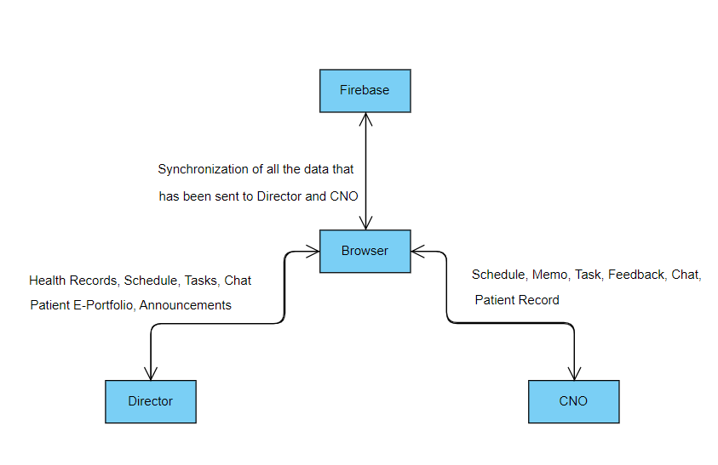

**Figure 1: Context Diagram**

#### APP Version

Figure 2 showcases a context diagram for the LTC-TMS. The purpose of the context diagram is to illustrate how each type of end user interacts with the applications and database.

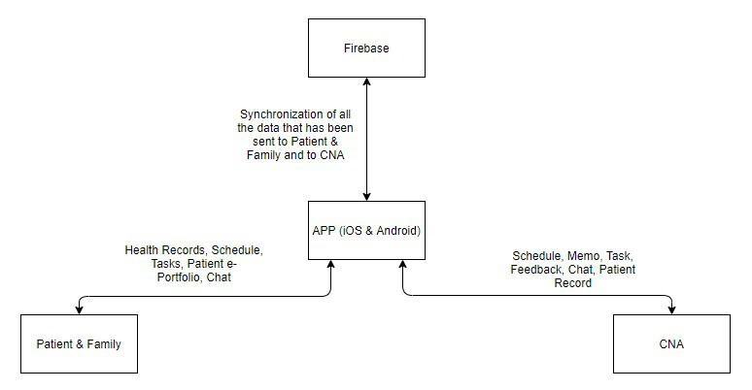

**Figure 2: Context Diagram**

## 2.3 Risk and Feasibility

This section examines various types of feasibility and how they could impact the

Project. The following section includes organizational and cultural feasibility, technological feasibility, resource feasibility, and schedule feasibility.

### 2.3.1 Organizational and Cultural Risks and Feasibility

As LTC-TMS applies to the LTC center, due to different conditions of LTC center such as staff, manager, hierarchy, culture and so on, the system might encounter several risks which are listed below.

* LTC staff are comfortable with existing, traditional operating procedures of the LTC center. There will be problems convincing them to switch over to the LTC-TMS. Also, the staff might have a low level of computer competency which will result in difficulties in using the system.

**Solution**: Providing training and long term technical support the LTC center will help alleviate any worries and problems, while customising the design of the system to match the organisations needs and operating practices as much as possible will make the transition simpler.

* Employee morale might be affected by the new system. The implementation of the system might make employees think that they will soon be replaced by technology and take a negative view towards the system.

**Solution:** Communicating with the employees that the new system is only there to assist them in their daily activities and ensuring that jobs are enhanced, not reduced.

* The director and CNO of the LTC center might assign the job and task to CNA to patient digitally. The director and CNO will therefore rarely meet with the patients and CNAs. This can lead to lack of physical contact and face to face meetings and lead to miscommunication because there are things that cannot be handled remotely.

**Solution**: Reminding the director and CNO that the Task Management System is no replacement for physical meetings will be important..

* The current hardware device is still quite bulky. The patients might be unwilling to wear the device, especially for long periods of time.

**Solution:** Minimise volume and mass of the wearable units. Asserting the uses and benefits the live monitoring provided will have towards the patient’s family and visitors.

* Cost relating to hardware will make clients unreceptive to the system.

**Solution:** Reduce per unit cost, increase supported number of connections to base station unit to improve scalability and focus clients on potential cost savings on traditional paperwork, efficiency improvements over non-integrated monitoring systems and increased visibility into operational processes.

### 2.3.2 Technological Risks and Feasibility

The LTC-TMS might require more technical tools to develop the system. It is important for the development team to list out all the possible technological risks and feasibility for problems that they might encounter. The developers are expected to think and come out with a solution for each feasibility.

* Lack of coding experience in developers working on the system.

**Solution**: Developers should focus on program design carefully before thinking about code implementation. Tutorials on coding can be learnt on the job, design cannot. Therefore, developers should examine problems carefully, and make sure they can design reliable solutions first before moving on to code.

* Insufficient equipment or software tools to establish the system.

**Solution**: Ensure sufficient hardware and software technology resources by purchasing or rent the tools.

* The LCT center database contains too many patients and too many user logs, exceeding database load.

**Solution:** Regular updates and maintenance to the system database to accommodate the patients, and delete user logs will be required in the long term.

* Poorly designed system components or unreliable performance may lead to a system crash, causing delays and loss of productivity for clients.

**Solution**: The developer must test and integrate their code carefully to ensure the system will function consistently and reliably. Bugs and errors found during operation will have to be fixed quickly in long term maintenance.

* Difficulty of determining technical feasibility for certain hardware changes due to granular nature of hardware parts and implementations.

**Solution:** Extensive research to determine possible feasibility. Determine risk and resource requirements are sufficiently low before proceeding to actual parts acquisition and testing.

### 2.3.3 Resource Risks and Feasibility

There are many types of resources needed to be considered in system risk and feasibility. Insufficient resources might cause delays and problems which lead to project failure. The resource risks and feasibility is listed as below:

* Developers do not have enough time to finish the assignments on time.

**Solution**: More communication with all the project members to manage time as best as we can depending on everyone's availability.

* The system might not be reliable or effective for the employees using it, the family members and also patients.

**Solution:** Developers should pay attention to resources such as skilled personnel, the physical facilities, relevant hardware components, and software to ensure a reliable system.

* The hardware has the possibility of being broken and it relates to patient security and the basic component to send the data to the whole system data flow.

**Solution:** Devices need to be checked weekly to make sure all devices are working properly.

* Developers do not have the knowledge of the operations in the LTC-center.

**Solution:** Development group will conduct research on various LTC and medical facilities in different areas to ensure the system is designed to be flexible and adaptable to differing LTC requirements in different circumstances.

* High cost of hardware parts and development.

**Solution:** Development and planning must proceed as carefully as possible. Choices in hardware are difficult to undo especially due to the differences in hardware platforms, and the behaviours of different variants of the same sensors. Careful decision making is vital to prevent unnecessary waste of resources. Also we should find a way to simulate additional wearable units to test base station scalability without needing to produce additional wearables.

### 2.3.4 Schedule Risks and Feasibility

This project commenced on (enter start date) which is expected to be fully completed by (enter the date we suppose to finish this project). The schedule should be defined and flexible enough to finish the application by considering the training, development, testing, unexpected delays, etc.

* The LTC-TMS development is not proceeding according to schedule.

**Solution**: All the developers must communicate effectively to adhere to strict deadlines. Failing to do so, the group must re-evaluate the delayed tasks, determine scope feasibility and restructure the development schedule.

* Developers do not have the skills necessary to apply the technology. The learning of new technologies necessary to complete the project will take time.

**Solution:** Determine whether deadlines are mandatory or desirable and try to learn only what is needed to complete important tasks first.

* Developers do not assign the work well and have different opinions in the work.

**Solution:**It necessary to plan ahead together and the members in a team needs to be a clear division of labor.

* Developers do not allocate time well and make us to do a lot of work in a short time.

**Solution:** It is necessary to make sure how much time that we have to finish the work and let us have more time to do it.

#### Work Breakdown Structure

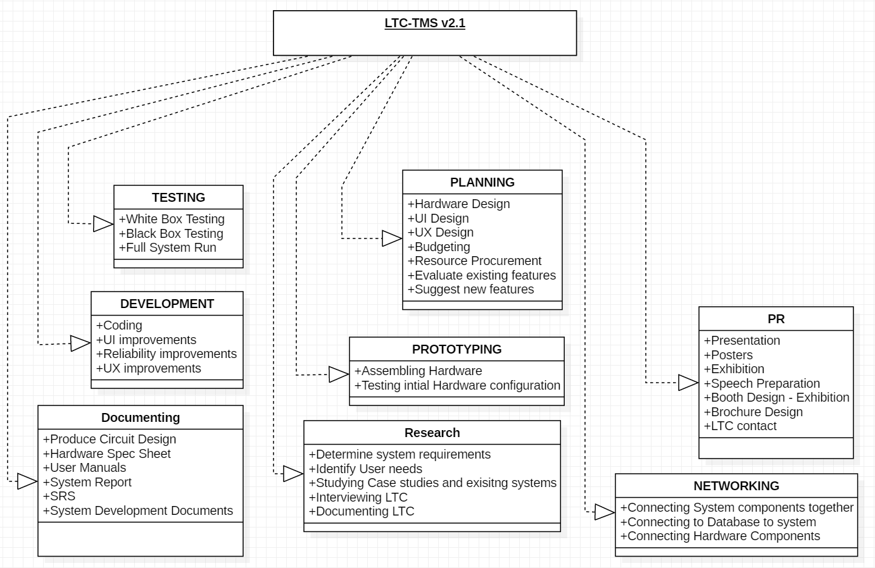

**Figure 3: Work Breakdown Structure**

#### Gantt Chart

A Gantt chart is a type of bar chart that illustrates a project schedule. **Figure 4** shows the remaining time of each task of LTC-TMS.

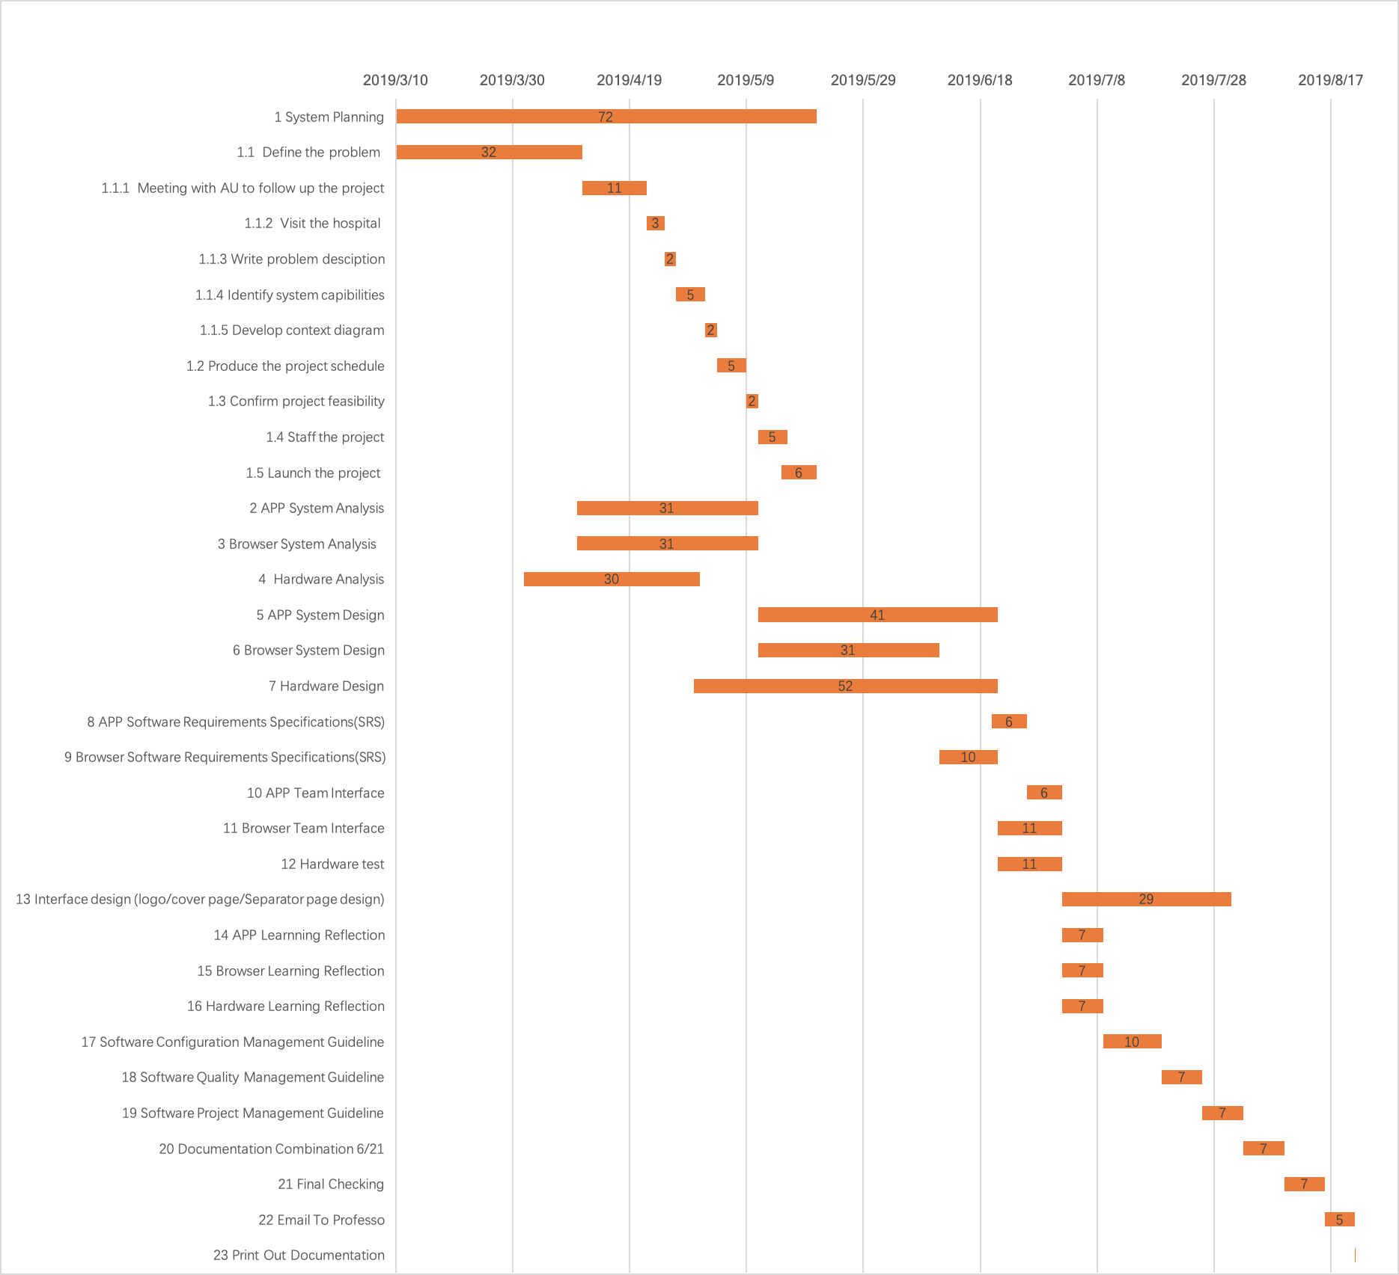

**Figure 4: Gantt Chart**

## 2.4 System Planning Conclusion

The goal of this LTC-TMS v2.1 project is to finish all the old and the new planned implementations successfully that makes this project more effective and simpler to use for all the users when it is compared to v2.0. Due to the coding language change in v2.0, the project suffered some setbacks but we are planning to put back all the functionality and add even more so it would increase work productivity and efficiency. Overall, the shift in our focus to improve Usability, reliability and scalability will make the system more attractive to potential clients and their user base.

Furthermore, it is unclear whether the LTC will be hesitant in implementing this system. Traditional ways of doing things are not easily changed and this can become an issue for us later on, so we should always keep that fact in the back of our minds. However, we are hoping that the new system will be accepted in a Taiwanese society that is very technology and “instant” driven.

# 3.0 System Analysis

System analysis is the process of studying a procedure or business in order to identify its goals and purposes and create systems and procedures that will achieve them in an efficient way.

## 3.1 Requirement Investigation

The purpose of requirement investigation is to specify the system requirement by identifying “what” could the system due to the stakeholders. Before identifying the requirement, investigation activity is required to be processed by the development team. The development team needed to understand what would the system do and what will be the minimum requirement to improve activity.

### 3.1.1 Stakeholder

There are four kinds of characteristics of stakeholders. Internal Stakeholders are those within the LTC center who interact with LTC-TMS. External Stakeholders are those outside the LTC center’s control and influence who also interact with LTC-TMS or have a significant interest in its operation and functions. Operational stakeholders are people who regularly interact with LTC-TMS. Executive stakeholders are persons who do not interact with LTC-TMS directly but who either use information produced by the system or have a significant financial or other interest in its operation and success. A list of stakeholders is given below.

**Internal-Operational Stakeholders:**

* CNA

**External-Operational Stakeholders:**

* Family

**Internal-Executive Stakeholders:**

* IT admin
* CNO
* Director
* Dean of LTC center

**External-Executive Stakeholders:**

* Customer Service Representative
* Investors

**Figure 5** is an investigation of stakeholders for the app version of LTC-TMS. All stakeholders are identified. Internal Stakeholders are the CNA. External Stakeholders are the Family. For Operational stakeholders, they are the CNA and the Family, who directly interact with the system. Executive stakeholders are CNO, Director, IT amin and Dean. Although CNO , IT admin and Director do not interact directly with the app version of LTC-TMS, the content in the system is mostly retrieved from the database in which the data is input from CNO,IT admin and Director.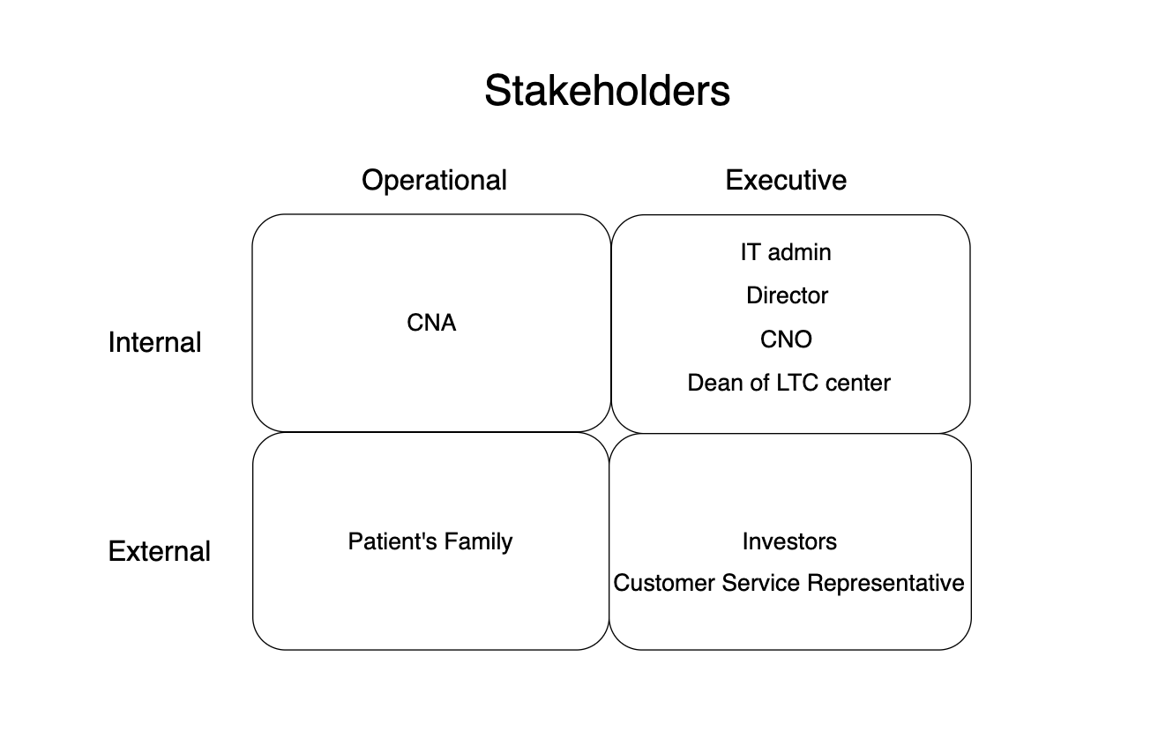

**Figure 5: Gantt Chart**

#### Hardware

The following is the analysis of stakeholders of the hardware phase. All stakeholders are defined. Internal Stakeholders ae the CNA, CNO to handle the data logs from the hardware devices. Operational Stakeholders are patients and CNA who directly work with the hardware devices. Executive stakeholders are the hospital manager/ director which will manually check whether system is work or not.

**Internal Stakeholders:**

* CNA/CNO

**Operational Stakeholders:**

* Patients
* CNA

**Executive Stakeholders:**

* Hospital manager
* Director

## 3.2 Use Cases

Use case is a list of actions or event steps typically defining the interactions between a role and a system to achieve a goal.

### 3.2.1 Use Case Diagram

#### Browser Version

**Figure 6** shows a complete use case diagram for the LTC-TMS Browser version.

Use cases describe activities that LTC-TMS in browser platform could perform which illustrate the interactions between actor(s) and the system.

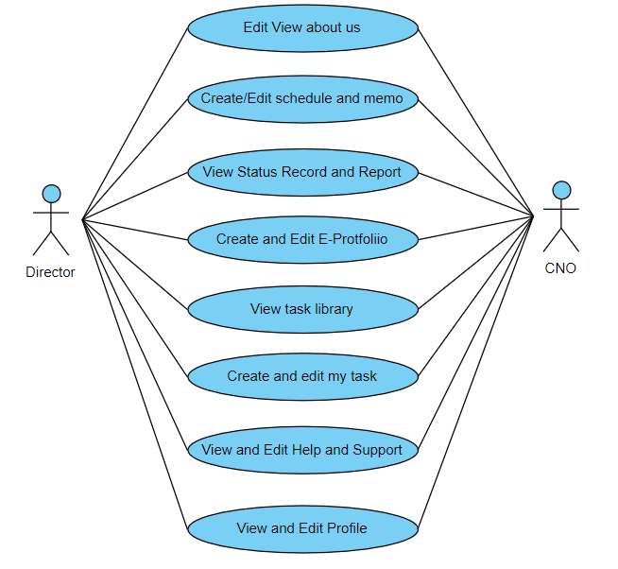

**Figure 6: Gantt Chart**

#### APP Version

**Figure 7** shows a complete use case diagram for the LTC-TMS APP version. Readers are able to understand more of the system function through the use case diagram and get a clear picture of the system. CNA and Family can all access to this system. Both can view task instruction, notification, schedule, announcement, and portfolio but only CNA can create, edit or modify certain parts of the system.

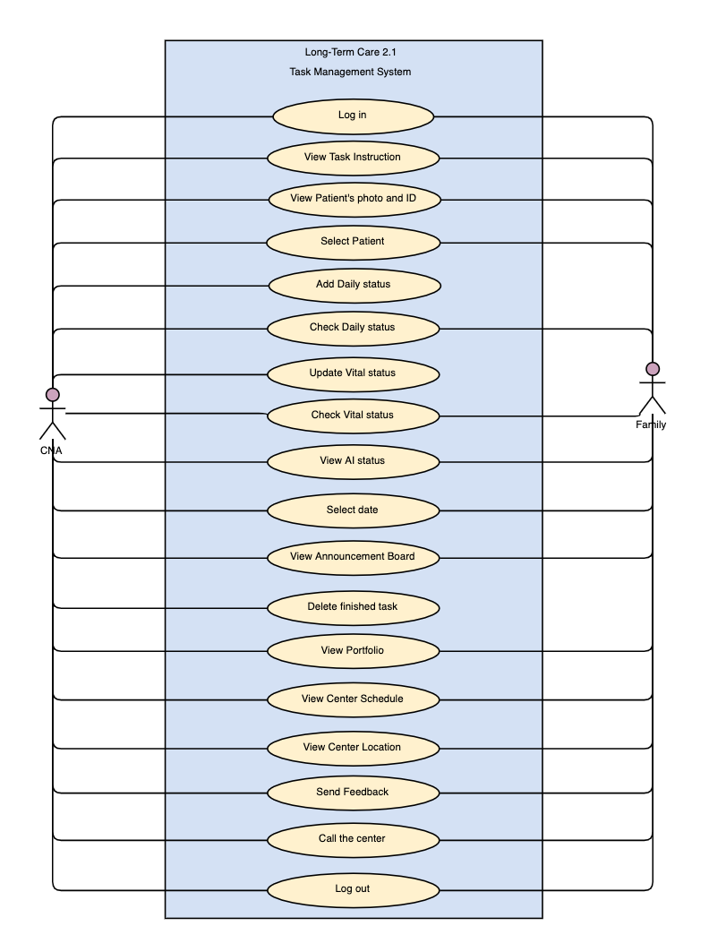

**Figure 7: Use case**

### 3.2.2 Brief Use Cases Description

The following tables are to show the brief description of the use cases.

#### Browser Version

**Table 1: Brief Use Case Description of LTC-TMS**

|  |  |
| --- | --- |
| Use Case | Brief use case description |
| Edit/View about us | User can view the information about the facility. If their account has permission, it can edit the information. |
| Create/Edit Schedule and Memo | The account which has permission can create and edit schedule and memo in the system and store in the database. |
| View Status Record and Report | The account which has permission can view status record and report of the patient. |
| Create and Edit E-Portfolio | The account which has permission can create E-portfolio for the new staff/patient and edit the E-portfolio into database if the staff/patient change their personal information. |
| View Task Library | The account which has permission can view the task in the library which store in the database. |
| Create and Edit My Task | The account which has permission can create and edit my task and stored in the database. |
| View and Edit Help and Support | Users can give feedback to the facility and view the support in the Help and Support webpage. |
| View and Edit Profile | The account which has permission can view and edit the profile and store in the database. |

#### 

#### APP Version

**Table 2: Brief Use Case Description of LTC-TMS**

|  |  |
| --- | --- |
| Use Case | Brief use case description |
| Log in | After login in the system, there is a page for Family to view and know the recent conditions about their patient, and this is kept up to date by the center. |
| View Task Instruction | The system provides tasks to be viewed on the task instruction page. Within the task, there are main steps and detail steps displayed, when CNA and Family click on the main step the system might return a video demo page, next, when CNA and Family click on detail step the system might return a photo demo page. |
| View Patients photo & ID | The system will provide CNA with all patients Photo next to their ID. Meanwhile, family members can only see their family members. |
| Select Patient | For family members, Patient record page will list all of the family members for the user to check their current status. Meanwhile, CNA will be able to access all of the patient's portfolio from the same page. |
| Add Daily Status | CNA will be able to add the daily status of the selected patient from Patient Record page. |
| Check Daily Status | CNA and the family member will both be able to check the patients daily status. So family members can get updated reports without being needed to call the center. |
| Update Vital Status | CNA will be able to Add Vital Status reports from the Patient Record page. |
| Check Vital Status | CNA and family members can check the patient’s blood pressure and even temperature. |
| View AI Status | CNA and family members can check the patient’s latest heart rate, the number of steps they took and even how many times the patient has fallen. |
| Select Date | When CNA wants to enter data for the patient in the Daily Status add, they will be able to change the date to add the data to another day. |
| View Announcement board | As long as the CNA and Family login into the system, they could view the LTC-TMS center announcement board on the home page. This enables each to view recent announcements with notifications of the latest news but cannot modify. |
| Delete Finished Task | When the CNA has done their task. They will have the option to remove that task until it reappears again. Doing that will not remove the task for all the CNAs but it will only remove from the CNA that has tried to remove. |
| View portfolio | The system provides a portfolio on the page. Whether it is the CNA or the family member, they can only view their own information is this page. |
| View Center schedule | The CNA and Family once login into the system, they can view the LTC center schedule on the Center Information page but cannot modify. |
| Send Feedback | Family members will be able to send feedback about anything whether it is about the center or about their family members who are getting treated. |
| Call the Center | Family members will be able to call the center from a convenient button in Center Info page. |
| Log Out | CNA and family members will both be able to log out from the Portfolio page. |

### 3.2.4 Activity Diagram

Activity diagram is basically a flowchart to represent the flow from one activity to another activity.

#### Browser Version

**Activity Diagram - Edit Schedule**

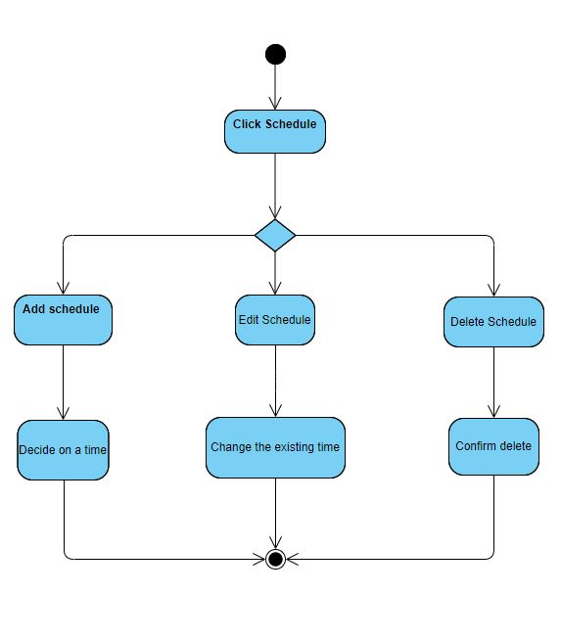

**Figure 8: Activity Diagram _Edit Schedule**

**Activity Diagram - Edit Memo**

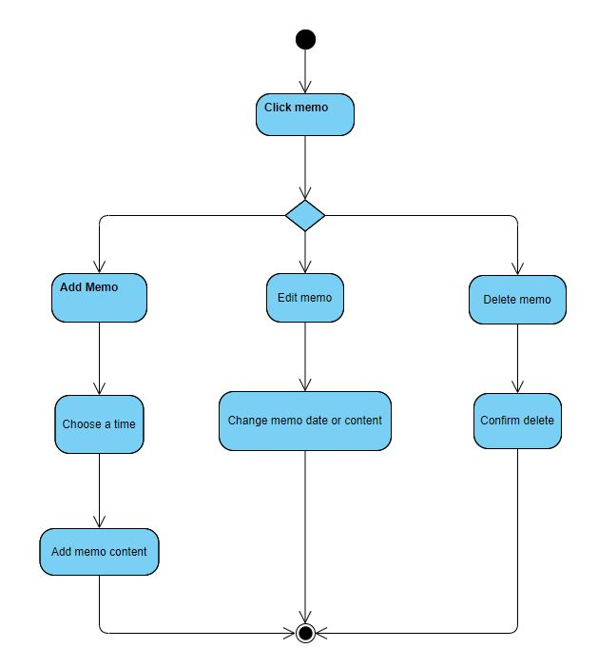

**Figure 9: Activity Diagram _Edit Memo**

**Activity Diagram - View Status Record**

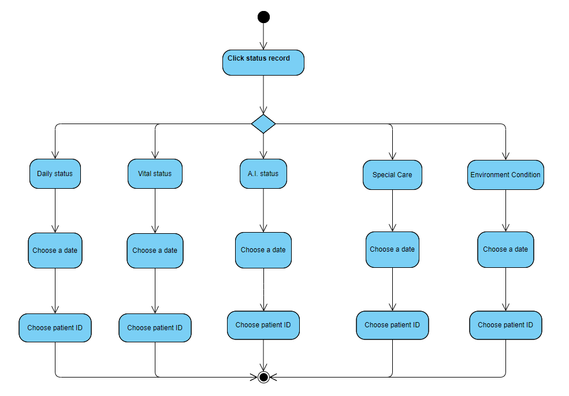

**Figure 10: Activity Diagram _View Status Record**

#### APP Version

**Activity Diagram - View Task Instruction**

First, CNA and Family click library. And it will show all the task instruction in it. CNA and Family are allowed to choose any one of them. After choosing one, CNA and Family can select to look at main steps or detail steps. The main step the system might return a video demo page, when CNA and Family click on detail step the system might return a photo demo page.

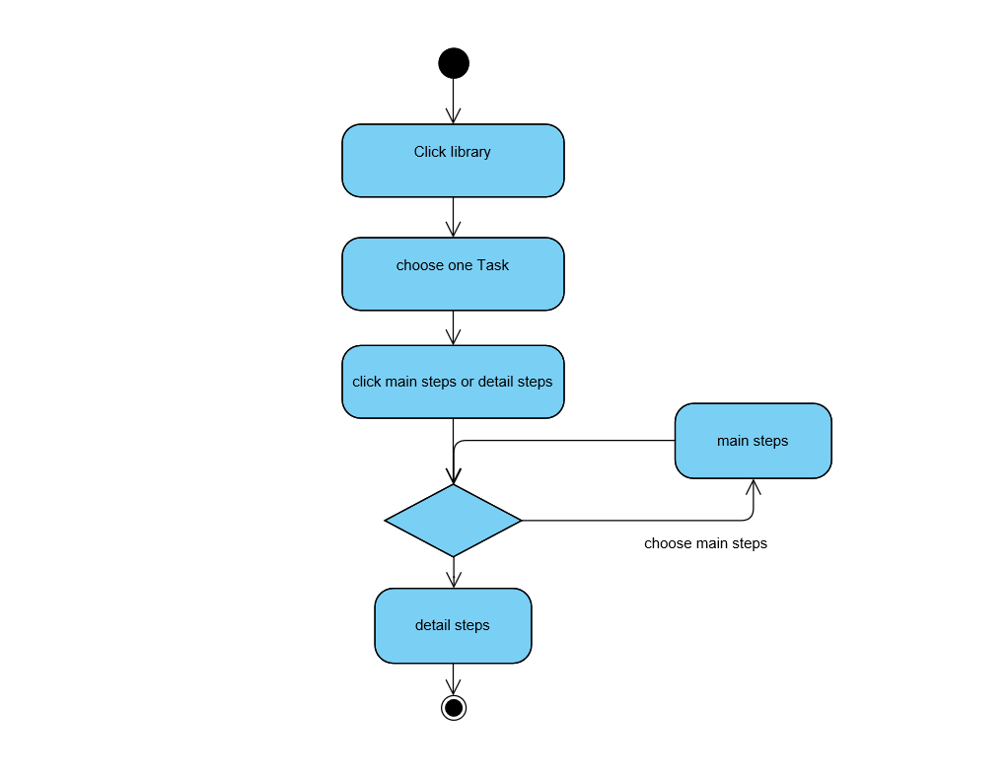

**Figure 11: Activity Diagram _View Task Instruction**

**Activity Diagram - Submit Feedback**

First, go to center info button page. And then click Submit Feedback. The application will jump to another page. In that page, you can choose two feedback type: Center and System. After you finish your typing. Click submit then the work is done.

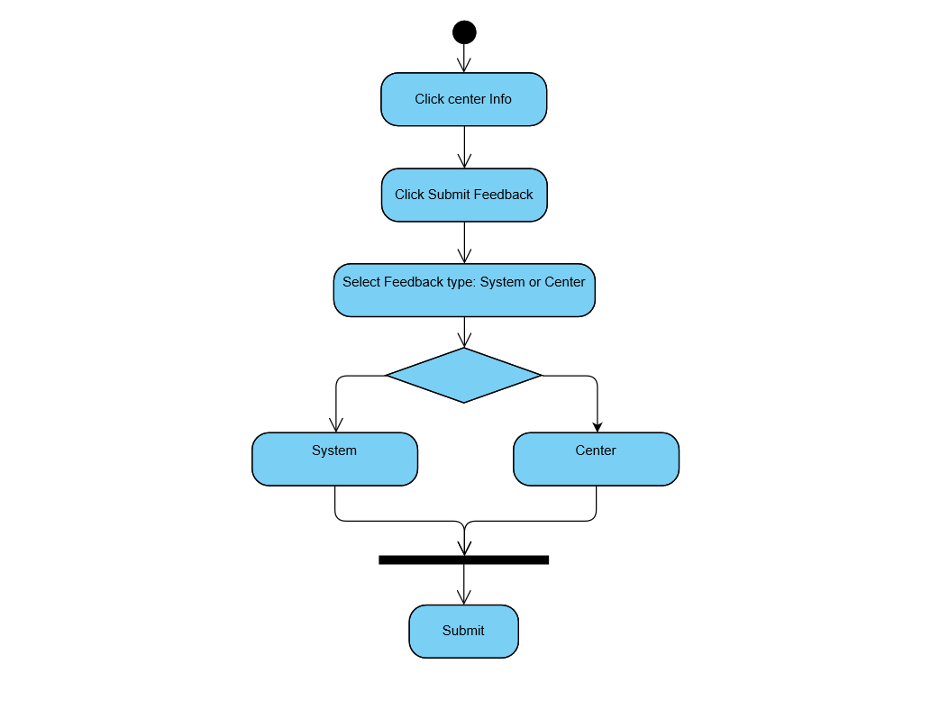

**Figure 12: Activity Diagram _Summit Feedback**

**Activity Diagram - Check Daily Status**

First, Go to portfolio page. Click check daily status button. The application will jump to another page. CNA can scroll to select which patient to check. After selecting patient and date, click the submit button will show that patient’s daily status in that day.

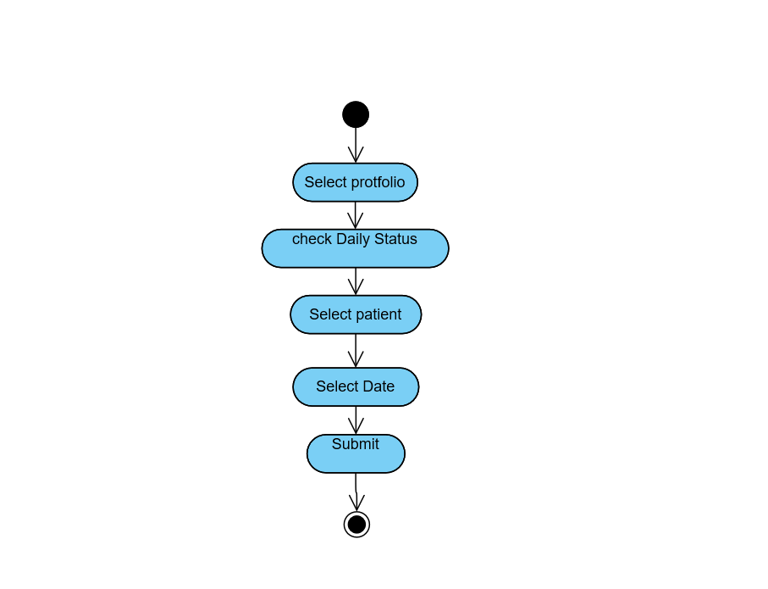

**Figure 13: Activity Diagram _Check Daily Status**

### 

### 3.2.5 System Sequence Diagram

A sequence diagram shows object interactions arranged in time sequence. It depicts the objects and classes involved in the scenario and the sequence of messages exchanged between the objects needed to carry out the functionality of the scenario.

#### Browser Version

In **Figure 14,** the System Sequence Diagram, the Director/CNO have entered logged into the system. Once logged in the Director/CNO will select the name of the patient. The Director/CNO is then able to enter the status record of the patient and confirm the status is correct, and generate the reports. After confirmation, the data is written to the Firebase database. The Director/CNO will then be returned to the previous data which is allowed to review.

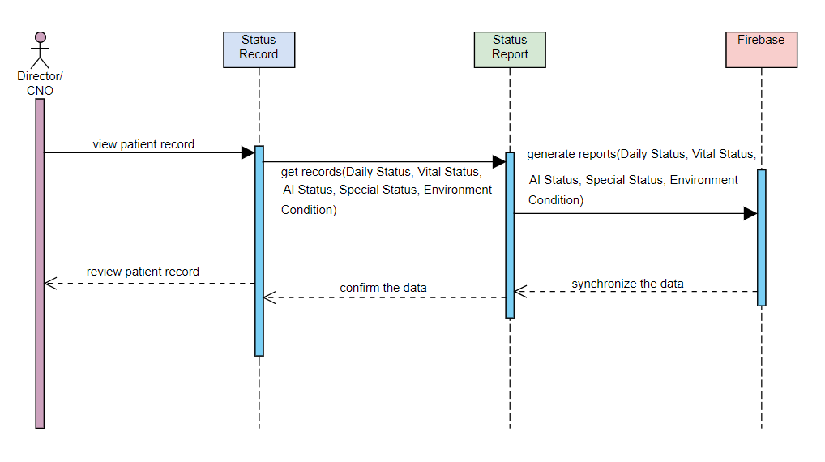 **Figure 14: System Sequence Diagram_Browser Version**

#### APP Version

In **Figure 15**, this Sequence Diagram, the CNA has entered the patient’s room and has logged into the system. Once logged in the CNA will select the name of the patient. The CNA is then able to enter the vital status of the patient and confirm the status is correct. After confirmation, the data is written to the Firebase database. The CNA will then be returned to the previous screen where they are able to continue their work.

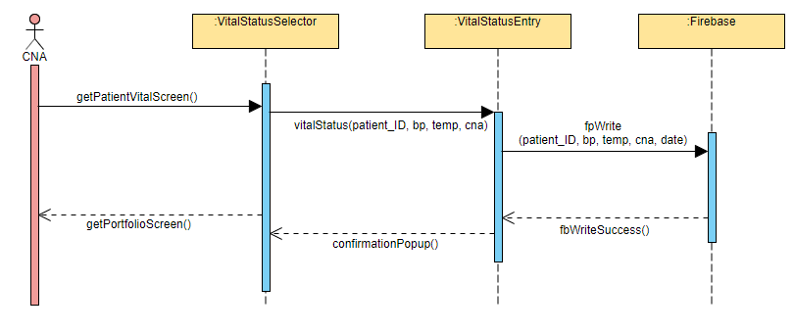

**Figure 15: System Sequence Diagram_App Version**

#### Hardware

The **Figure 16** below outlines the sequence regular communication operations for the HW base station.

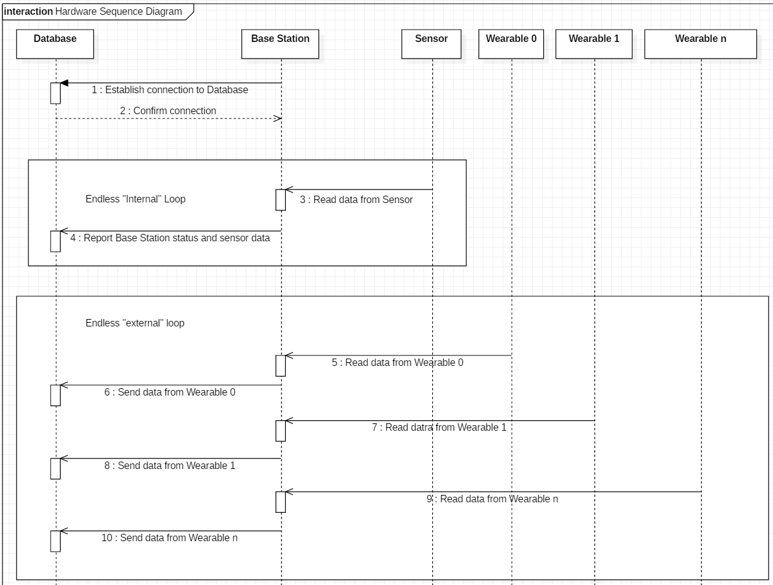

**Figure 16: System Sequence Diagram_Hardware**

### 3.2.6 Domain Class Diagrams

Domain class diagram is used to show classes of objects for the LTC-TMS. Domain class diagrams are fundamental to the object modeling process and model the static structure of a system. Depending on the complexity of a system, you can use a single class diagram to model an entire system, or you can use several class diagrams to model the components of a system.

### 3.2.7 State Machine Diagram

State machine diagram is a behavior diagram which shows discrete behavior of a part of designed system through finite state transitions.

#### Browser Version

#### **I. State Machine Diagram - Portfolio**

**Figure 17** is a state machine diagram for the class of portfolio. There are three states for portfolio, which are creating, displaying and editing states. First of all, when the user request to create a new portfolio, the portfolio will move to creating state. Then after the user finish with the input and upload the portfolio, the portfolio will move into the displaying state. In the case that the user need to edit the information in the portfolio, the portfolio will move into the editing state. After the user finish editing, the portfolio will move back to the displaying state. Lastly, when the user decides to delete the portfolio, the portfolio lifeline is terminated.

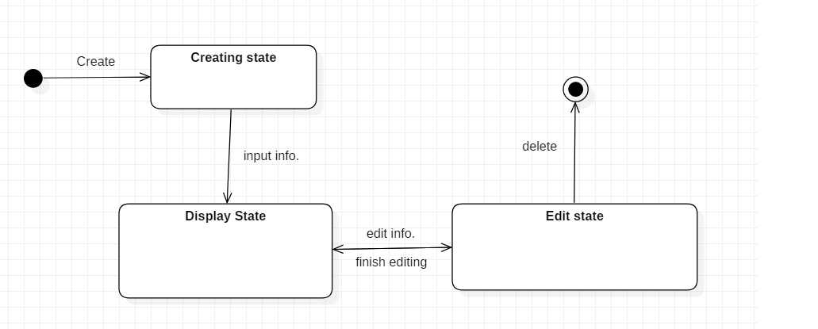

**Figure 17: State machine diagram_protfolio**

#### **II. State Machine Diagram - Memo**

**Figure 18** is a state machine diagram for the class of memo. There are three states for portfolio, which are creating, displaying and editing states. First of all, when the user request to create a new memo, the portfolio will move to creating state. Then after the user finish with the input and upload the memo, the portfolio will move into the displaying state. In the case that the user need to edit the information in the memo, the memo will move into the editing state. After the user finish editing, the memo will move back to the displaying state. Lastly, when the user decides to delete the portfolio, the portfolio lifeline is terminated.

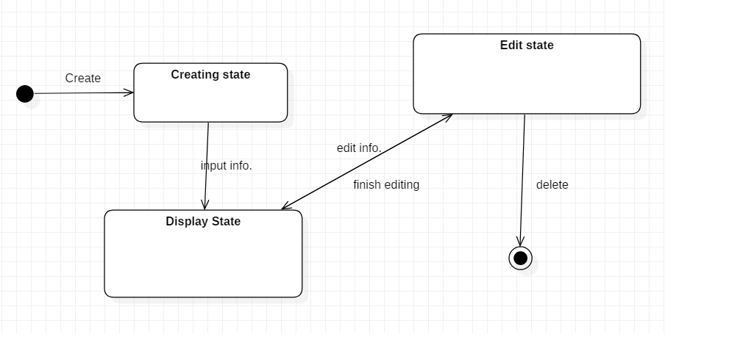

**Figure 18: State machine diagram_memo**

#### **III. State Machine Diagram - My Task**

**Figure 19** is the state machine diagram for the class of task. There are four states for task instruction; creating, storing, displaying and editing. To start with, when the user request to create a task, the task instruction will move to creating state. After the user finished with the input and upload, the task instruction will move into the storing state. After the storing state is finished processing, the system will add the task to the library and will move to displaying state. In the occasion that the user wishes to edit any of the task, the task will move into the editing state. After finishing inputting and editing to the new information, the task instruction will move into the storing state and displaying state accordingly when the task instruction have been uploaded to the library. Finally, when the user decides to delete the task, then the lifeline of the task instruction is aborted.

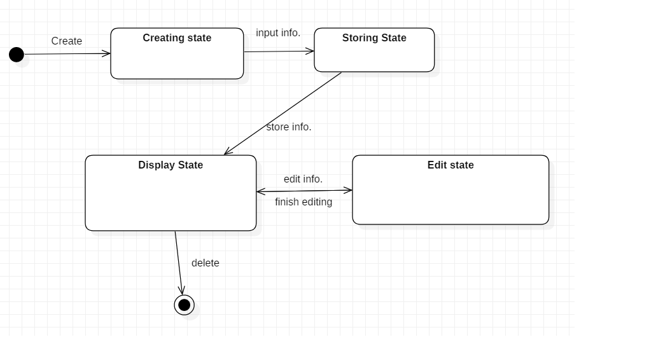**Figure 19: State machine diagram_memo**

## 3.3 System Analysis Conclusion

In this system analysis document, the development team has made and drawn use case diagram, use case brief description, fully developed use case description, activity diagrams, system sequence diagrams, domain class diagram and state machine diagrams for LTC-TMS v2.1. The development team has provided the diagrams to imply and deliver our ideas for the new system that is going to be built.

Furthermore, readers could view that both Director, CNO, and CNA are able to interact with most of the functions of the system. Our target for creating this system is to digitize data in the Long-term care center to prepare for the coming aging future population. Since the number of elderly is increasing, there might be a lot of elderly people that will be entering the LTC center. In order for the Director, CNA, CNO and other staff to work conveniently and effectively, this information system should help them to manage the task, profiles, records, and data.

# 4.0 System Design

Systems design is the process of defining the architecture, modules, interfaces, and data for a system to satisfy specified requirements.

## 4.1 Network Design Diagram

A network diagram is a visual representation of a computer or telecommunications network. It shows the components that make up a network and how they interact, including routers, devices, hubs, firewalls, etc.

#### Browser Version

We host the website from the firebase server and also set the database on the firebase. The pc or laptop connected to the internet by passing your router and visit the website on the browser.

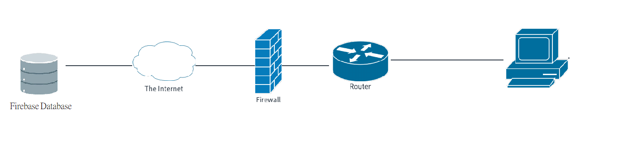

**Figure 20: Network Design diagram_browser**

#### APP Version

Routers let multiple devices share a common Internet connection from your ISP (Internet Service Provider). This applies to cable, DSL input, or by 3G mobile using USB Dongle. Routers support NAT, meaning Network Address Translation. This means that the Public IP address is assigned to the router, and not to any of the PC's on the Local ( LAN ) side of the router. A computer connected directly to the ISP cable connection is subject to attack. The presence of a router improves security. Some routers have firewalls providing considerable protection against hacking into your network. Routers monitor network usage and can send email alarms when abnormal things happen.

NETGEAR wireless routers support WPA. This gives you extremely strong encryption for your wireless data. Routers have Parental Controls. This means filtering that stops children to access forbidden http// websites. A firewall is a system designed to prevent unauthorized access to or from a private computer network. Firewalls are frequently used to prevent unauthorized Internet users from accessing private networks connected to the Internet.

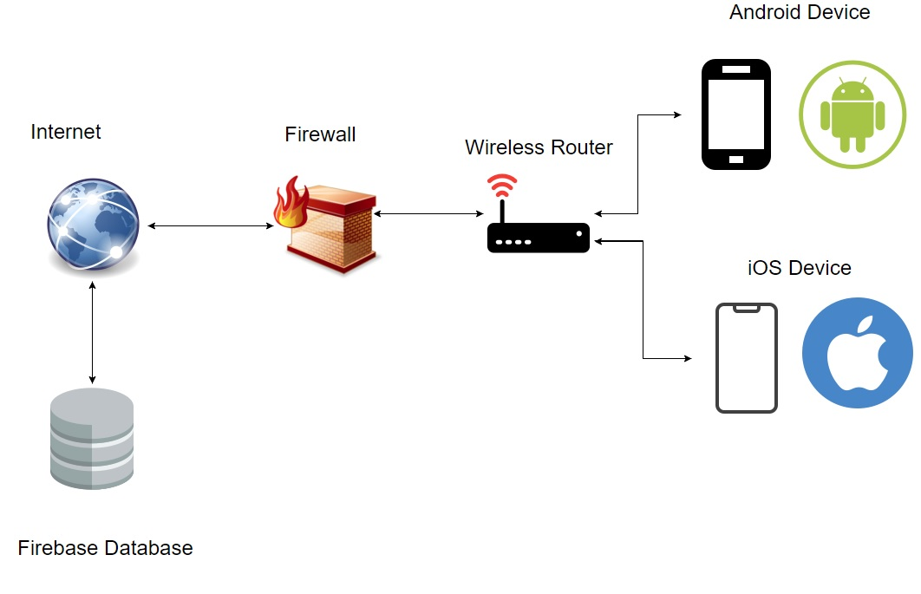

**Figure 21: Network Design diagram_browser**

## 4.2 Device Design Diagram

We will talk about what we are the changes that we want to do on our device in this chapter.

#### HARDWARE PHASE

The following diagram shows the KU device design:

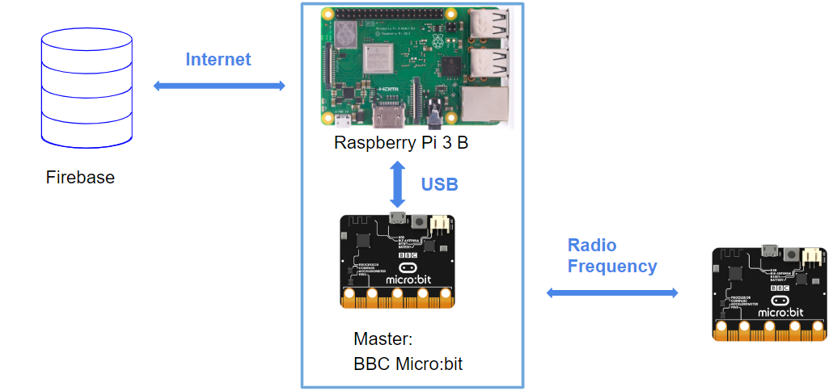

**Figure 22: Device Design Diagram_KU**

Basically, we want to modify LTC-TMS2.0’s current communication relationships which operate on a one to one basis from base station to wearable, to a one to many relationship from one base station to multiple wearables. This is intended to improve system scalability and decrease installation costs. Raspberry Pi 3 B+ will communicate with the database through a Wi-Fi connection and used USB to connect to the Master BBC Micro:bit. The Master Unit will be responsible for connecting with the Slave units through Radio Frequency.

The sensor will connect through I²C on the required unit they would be put. For example, the heart rate sensor will connect with the slave unit BBC Micro:Bit. Air quality sensor will connect with Raspberry Pi 3 B+. The following diagram shows the general connection between hardware device.

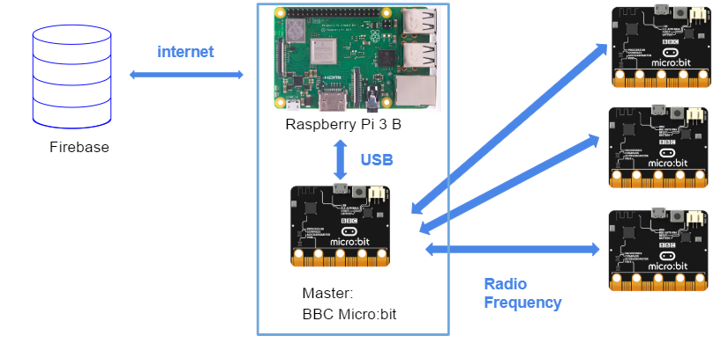

**Figure 23: Device Design Diagram_MCU**